Comp 1004 - 27/9/23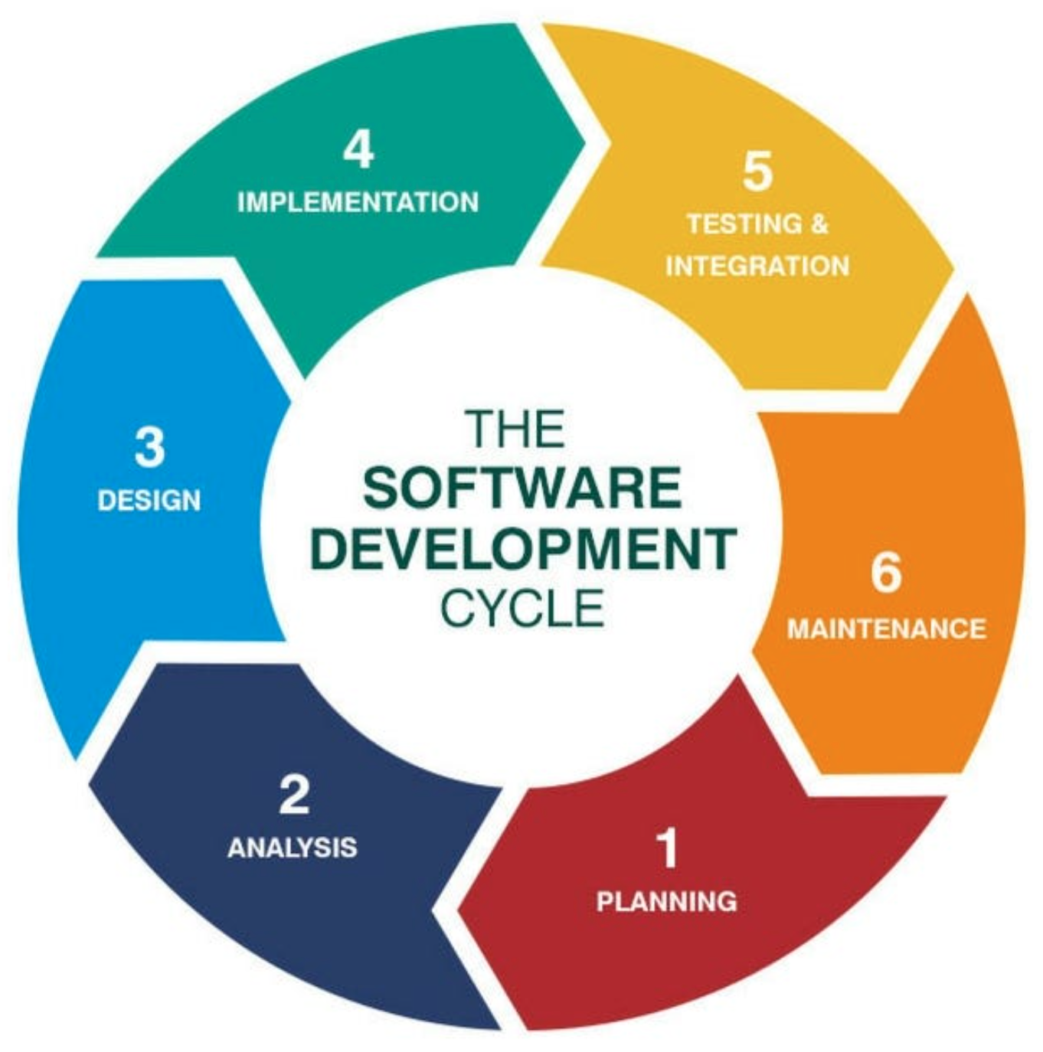

Software Development Life Cycle - SDLC

1. Planning – Defining the application, what the application will do (login system, dashboard page, etc)
2. Requirement analysis – Defining the requirement (the login page will have a username/password fields, buttons, load data from a database, etc)
3. Design – Take all the requirements and design the application. What programming language to use? What frameworks? UML diagrams?
4. Implementation - Coding
5. Testing – Unit testing, integration testing, user testing, etc
6. Deployment - The system is deployed and installed in customer’s premises
7. Maintenance